Session 22
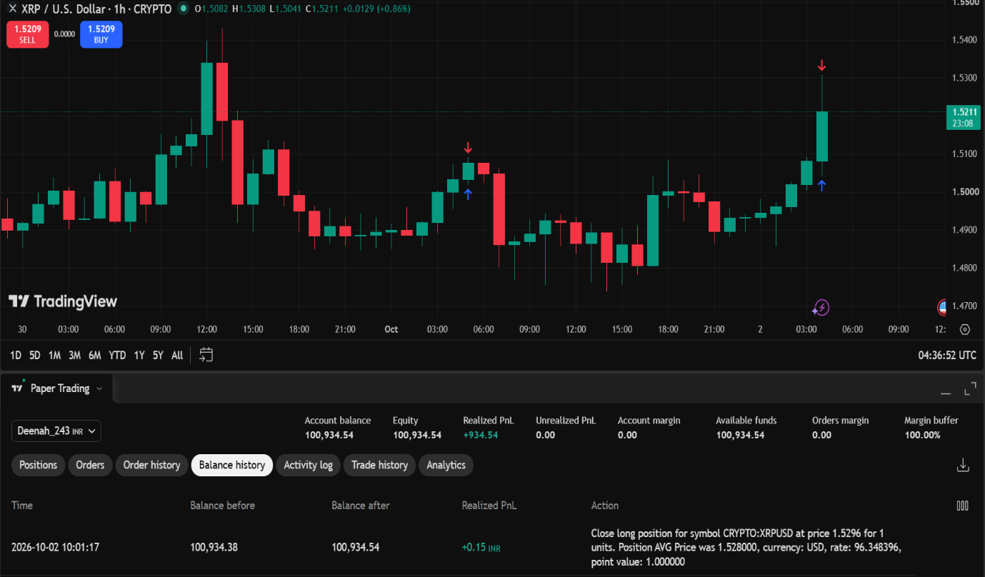
Field | Details
Asset | XRP / USD (XRPUSD)
Trade Date | 2026-10-02
Trade Strategy Used | Long trade / buy-the-position strategy ("Close long position for symbol CRYPTO:XRPUSD")
Trade Status | Closed
Entry Price | $1.5280
Current / Exit Price | $1.5296
Profit / Loss | Profit
Profit / Loss Amount | +0.15INR
Was the Original Trading Plan Followed? | No — the long position was opened near the recent high of a sharp bullish candle (around 1.5280) and quickly closed after a minimal move of +0.0016 USD before establishing clear structural confirmation or reaching a defined target.
Reason for Profit / Loss | The trade was closed slightly above the average entry price ($1.5296 vs $1.5280), generating a small profit of 0.15 INR.
Key Learning | Taking small profits without sticking to predefined stop-loss and take-profit targets can encourage emotional execution. Ensure every entry is backed by a full multi-factor checklist (trend alignment, support/resistance levels, moving average confluence) and allowed to run according to a proper risk-to-reward ratio.

Session 23
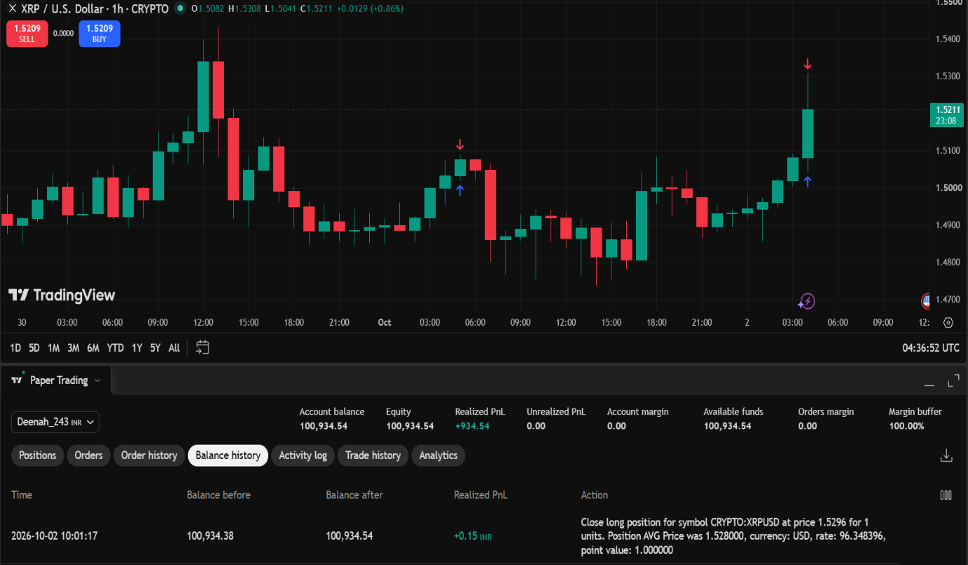

Trading Journal
Field | Details
Trade Date | 02 Oct 2026
Trading Strategy Used | Long trade / Buy-the-position strategy
Trade Status | Closed
Entry Price | $1.5280
Exit / Current Price | $1.5296
Profit / Loss | +0.15 INR profit
Reason for Entering the Trade | Entered a long position near the top of a strong green candle (1.5280) expecting momentum to continue higher towards 1.5400+. However, entry occurred without a full trend pull-back or structural confirmation.
Was the Trading Plan Followed? | No. The position was executed near local resistance and quickly closed after a minimal upward move of +0.0016 USD rather than waiting for a complete setup alignment and target test.
What Went Well? | The trade closed in positive territory (+0.15 INR profit) and was properly logged and documented in the paper trading journal.
What Challenges or Mistakes Did You Observe? | Chasing momentum near the high of an expansion candle led to an early exit. Entering without setting explicit Stop-Loss and Take-Profit orders upfront creates unnecessary emotional trading and micro-scalping.
What Will You Do Differently in Your Next Trade? | I will wait for price to test a key support level or 50 SMA confluence before going long, and I will define my Stop-Loss and Take-Profit limits before opening the order.
Key Learning | Execution discipline is more important than a small positive PnL. A trade closed with a tiny gain from impulse buying can build bad habits; always adhere strictly to the 5-point strategy checklist before executing.

Session 24
Field | Details
Total Number of Trades | 1
Number of Closed Trades | 1
Number of Open Trades | 0
Number of Profitable Trades | 1
Number of Unprofitable Trades | 0
Total Realised Profit/Loss | +0.15 INR
Total Unrealised Profit/Loss | 0.00
Most Frequently Used Strategy | Breakout / Momentum Long Trade Strategy
Best Performing Strategy | Long / Buy-the-position trade (+0.15 INR)
Common Strengths Observed | Analyzed market structure and price action before opening the position. Accurately recorded trade timestamps, order values, and balance changes in the paper trading journal.
Common Mistakes Observed | Entered a long trade near the peak of a bullish expansion candle (1.5280) without waiting for structural confirmation or a pullback. Scalped the position early for a tiny gain (+0.0016 USD move) rather than letting a planned trade hit predefined Stop Loss / Take Profit targets.
Overall Trading Discipline | ☐ Excellent ☑ Good ☐ Needs Improvement
Improvement Plan for Future Trades | Always verify all 5 core technical factors before entry: Trend Direction, Market Structure (HH/HL), Support/Resistance levels, 50 SMA location, and RSI confirmation. Set predefined Stop-Loss (SL) and Take-Profit (TP) bracket orders upon entry to eliminate impulse closing.
Key Learning | Realizing a positive PnL does not mean the trading plan was strictly followed. Execution quality and rule adherence must always take precedence over small short-term profits.

